**Software Requirements**

**Specification**

**for**

**L.A.P.A**

**Prepared by Bernard Bollinger III, Phillip Han, Brian Kan, Sharon Lake, Araceli Lopez, Patricia Luz, Kaila Mayho**

**L.A. City Bureau of Engineering**

**September 8, 2017**

# **Table of Contents**

Table of Contents.................................................................. <pg 2>

Revision History.................................................................... <pg 3>

1. Introduction............................................................... <pg 4>
   1. Purpose............................................................... <pg 4>
   2. Intended Audience and Reading Suggestions............ <pg 5>
   3. Product Scope...................................................... <pg 5>
   4. Definitions, Acronyms, and Abbreviations ...............<pg 5>
   5. References...........................................,............... <pg 5>
2. Overall Description.....................................................…. <pg 6>
   1. Product Perspective............................................... <pg 6>
   2. Product Functions................................................ <pg 6, 7>
   3. User Classes and Characteristics............................. <pg 8>
   4. Operating Environment.......................................... <pg 8>
   5. Design and Implementation Constraints................... <pg 8>
   6. User Documentation.............................................. <pg 8>
   7. Assumptions and Dependencies............................. <pg 8>
   8. Apportioning of Requirements................................. <pg 8>
3. External Interface Requirements.................................... <pg 9>
   1. User Interfaces.................................................... <pg 9>
   2. Hardware Interfaces.............................................. <pg 9>
   3. Software Interfaces.............................................. <pg 9>
   4. Communications Interfaces................................... <pg 9>
4. Requirements Specification........................................... <pg 10>
   1. Functional Requirements....................................... <pg 10,11>
   2. External Interface Requirements............................ <pg 12>
   3. Logical Database Requirements............................. <pg 12>
   4. Design Constraints............................................... <pg 12>
5. Other Nonfunctional Requirements.................................. <pg 13>
   1. Performance Requirements.................................. <pg 13>
   2. Safety Requirements........................................... <pg 13>
   3. Security Requirements.......................................... <pg 13>
   4. Software Quality Attributes................................... <pg 13>
   5. Business Rules..................................................... <pg 13>
6. Other Requirements..................................................... <pg 14>

Appendix A: Glossary............................................................ <pg 15>

Appendix B: Analysis Models................................................... <pg 16>

Appendix C: To Be Determined List.......................................... <pg 17>

# **Revision History**

|  |  |  |  |
| --- | --- | --- | --- |
| **Name** | **Date** | **Reason For Changes** | **Version** |
|  |  |  |  |
|  |  |  |  |
|  |  |  |  |
|  |  |  |  |

**<Add rows as necessary when the document is revised. This document should be consistently updated and maintained throughout your project. If ANY requirements are changed, added, removed, etc., immediately revise your document.>**

# **1. Introduction**

L.A.P.A is a cross platform mobile application that will allow employees, from here on will be referred to as User(s), of the Bureau of Engineering to take relevant photos while working on any project, tag said photo with relevant information, and store it in the cloud. The User(s) will also be able to tag and upload photos not taken within the app to the cloud; as well as, recall all photos stored in the cloud through the app.

## **1.1 Purpose**

The purpose of this document is four-fold:

The purpose of this document is four-fold:

1. Completely define a full set of requirements for the  **L.A.P.A** - Section 3.0
2. Completely define the design for the  **L.A.P.A – Section 4.0**.

c) Define and partially implement feasible modules for the  **L.A.P.A – Section 5.0**.

d) Completely define the Test Plan for the  **L.A.P.A** **– Section 6.0**.

The complete definition of all **L.A.P.A** requirements provides the source requirement inputs for the development of the subsequent supporting software subsystems documents.

## **1.2 Intended Audience and Reading Suggestions**

Developers, project managers, testers and documentation writers. The SRS contains an overall description of the project as well as the specific functional requirements of the app itself.

## **1.3 Product Scope**

The app will serve as an interface between the currently existing web application and Microsoft Azure Database. It will be primarily used by the Sidewalk Repair Program, but it is expected to expand to other departments in LA City.

## **1.4 Definitions, Acronyms, and Abbreviations**

Android: A mobile OS platform.

App: An Android-Specific Application.

LAPA: Los Angeles Photo Archive

DB: Database.

## **1.5 References**

PABOE SRS v1.0

# 

# **2. Overall Description**

## **2.1 Product Perspective**

The app will serve as an interface between the currently existing web application and Microsoft Azure Database. It is currently unknown if any proprietary software is similar to this, but their is no publicly available software which is similar to this.

## **2.2 Product Functions**

**Product Functions**

* LAPA will mark photos as before and/or after.
* LAPA uploads photos to an Azure database.
* LAPA will take a photo with either the camera or retrieve it from their gallery.
* LAPA will associate metadata with the photo which is how the photo gets transferred to the web link and the Azure database.
* LAPA will be launched from a pre-existing web application.
* LAPA can mark a photo as the primary photo for a repair task.

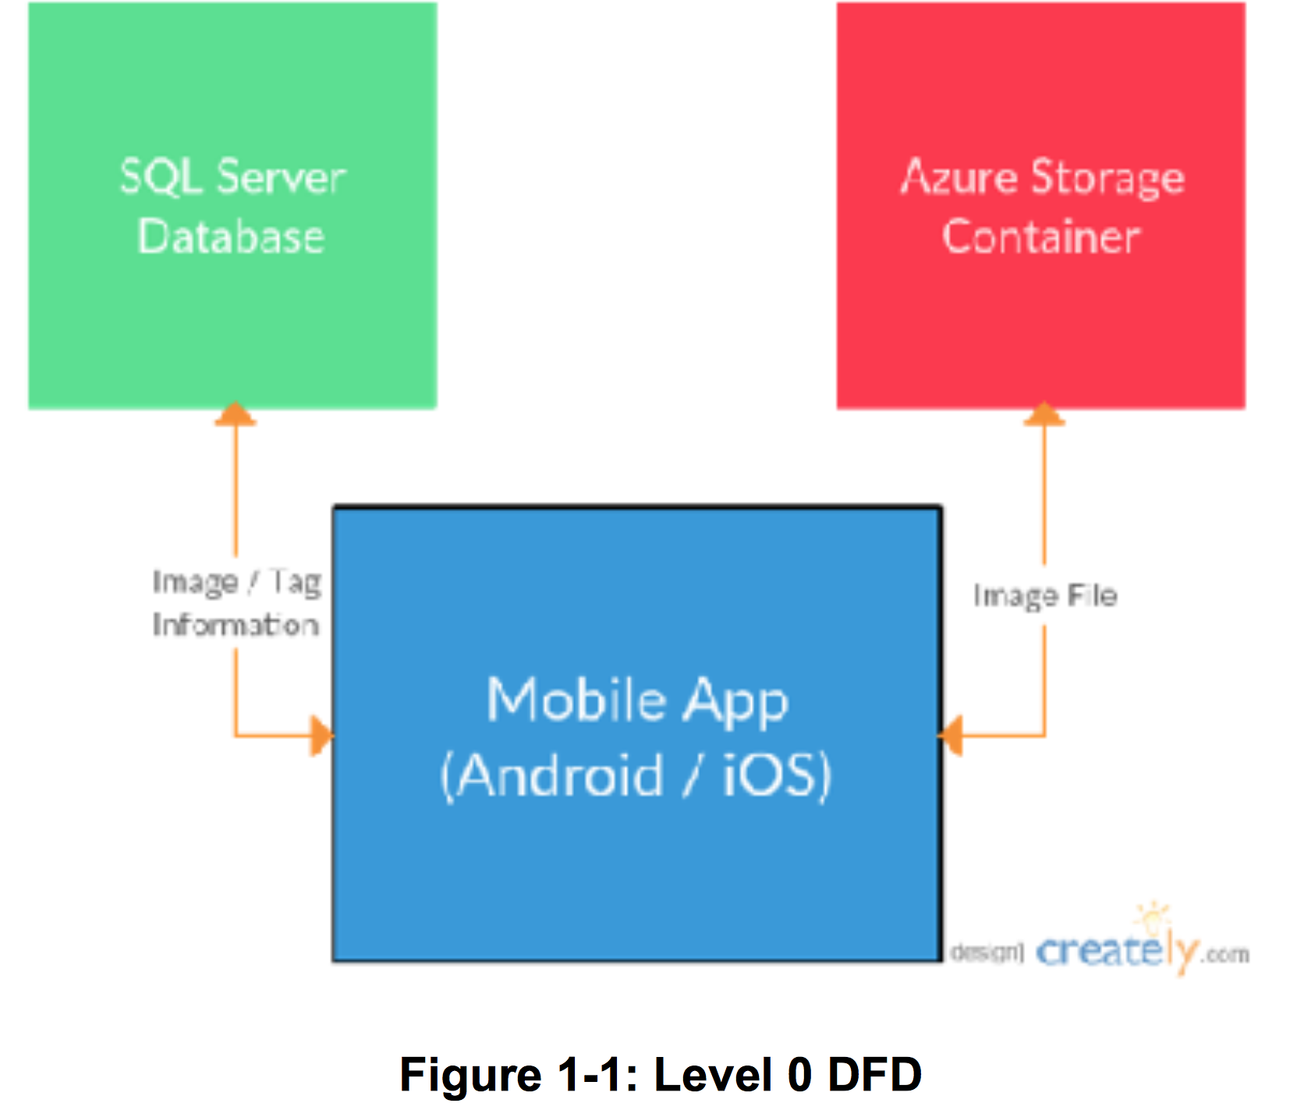

## **2.3 User Classes and Characteristics**

## **2.4 Operating Environment**

Android 4.0+ (KitKat) .

## **2.5 Design and Implementation Constraints**

## We do not have a link to their webpage where they want to photos to be stored.

## **2.6 User Documentation**

Requirements Documentation (Word Document)

Design Documentation (Word Document)

Database Schema (PNG Diagram)

## **2.7 Assumptions and Dependencies**

1. The phone is running at least KitKat(4.0) Android.
2. The phone is capable of internet access.
3. The phone has a functioning browser.
4. The phone is equipped with a camera.

## **2.8 Apportioning of Requirements**

1. Implementation of the iOS application.
2. Implementation across all LA city departments.

# **3. External Interface Requirements**

## **3.1 User Interfaces**

Android Phone

Android Tablet

## **3.2 Hardware Interfaces**

Android Phone (4.0+)

Android Phone Camera

## **3.3 Software Interfaces**

1. Microsoft Azure Mobile Services

## **3.4 Communications Interfaces**

1. A functional Android web browser application.
2. Internet access.

# 

# 

# 

# 

# 

# **4. Requirements Specification**

## **4.1 Functional Requirements**

## Requirements Associated with Application Launching

|  |  |
| --- | --- |
| Requirement No. | Requirement Description |
| 4.1.1 | LAPA shall be launched from a web application link that contains a username and Repair Task ID. |
| 4.1.2 | LAPA shall prompt the user to enter their name and permit number or Job identification number. |

## Requirements Associated with Application Uploading

|  |  |
| --- | --- |
| Requirement No. | Requirement Description |
| 4.1.3 | LAPA shall prefill the username and Repair Task ID fields based on the link used to launch the application. |
| 4.1.4 | LAPA shall provide a list of photo categories and subcategories for the user to choose from. |
| 4.1.5 | LAPA shall upload photos to a Microsoft Azure Blob Container. |
| 4.1.6 | LAPA shall be to insert records with the Microsoft Azure Blob Storage link, Repair Task ID, username, latitude, longitude, before/after, and primary image into a Microsoft Azure SQL table. |

## 

## Application Pulling Photos

|  |  |
| --- | --- |
| Requirement No. | Requirement Description |
| 4.1.7 | LAPA shall pull pre-existing photos associated with the Repair Task ID from the Microsoft Azure Blob Storage. |
| 4.1.8 | LAPA shall pull a list of categories and subcategories, Azure Blob Storage links, Repair Task ID, before/after, latitude and longitude from the Microsoft Azure SQL DB. |

## **4.2 External Interface Requirements**

Android Phone

Android Tablet

## **4.3 Logical Database Requirements**

1. The database shall be using the Microsoft Azure API.
2. The database shall associate the photos with metadata.
3. The database shall pass photos to the application.
4. The database shall receive photos from the application.
5. The database should support image storage.
6. The database should be using Azure Mobile Services.

## **4.4 Design Constraints**

# We don’t have direct access to their database.

# 

# 

# 

# 

# **5. Other Nonfunctional Requirements**

## **5.1 Performance Requirements**

**N/A**

## **5.2 Safety Requirements**

* **Microsoft SSMS**

## **5.3 Security Requirements**

**N/A**

## **5.4 Software Quality Attributes**

* **Ability to change the categories are needed from within PABOE**

## **5.5 Business Rules**

**N/A**

# **6. Other Requirements**

# iOS is not a priority.

# They plan to use this app this year.

1. Security is not an issue.

# **Appendix A: Glossary**

# **Appendix B: Analysis Models**

# **Appendix C: To Be Determined List**

# External Interfaces

1. Analysis Models
2. User Documentation